Press release rational einbauküchen GmbH

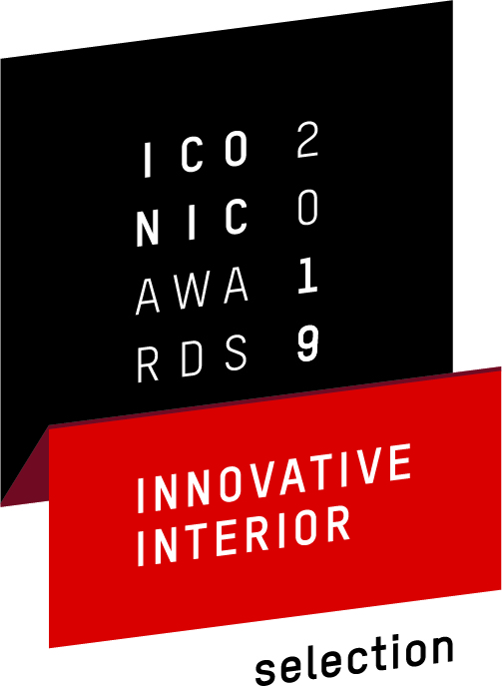
Yet more accolades for rational

In times of complex digital systems, clean linear shapes and a pared back design have a calming, relaxing effect. Important too is providing kitchen specialist retailers with an attention-grabbing anchor point. That's why rational has developed the cascade design frame for combining with any of the fronts from its wide range of doorstyles and which lends every custom-planned kitchen its own unique signature.

This new development has now brought rational a further award:
the Iconic Innovative Interior Award 2019 .The filigree cascade frame means that base, wall or tall units are no longer seen as solitary pieces but are presented as design elements within an integrated concept. In addition to this award, the cascade design frame developed by rational has been registered as a protected patented design by the German Patent and Trademark Office.

Following development of the highly flexible interior organization system passe|par|tout, the designer kitchen floo, created in collaboration with the international designer Karim Rashid, the filigree frame cascade now represents a further USP that rational has developed exclusively for its kitchen specialist dealers.

Your contact:

Elke Pfeiffer
Head of Marketing
T +49 5226 58-330
epfeiffer@rational.de

If any of this information is published, please send us a voucher copy.

